Original Article

Intra-lingual suture pattern for prevention of self-suckling in cows

A.M. Seddek ª,*, M. Abdelfattah ^{b}, M.H. Elrashidy ª, F.A. Mahmoud ^{c}, F.A. Zakaib ^{d}

ª Surgery, anesthes. & rad. Dept., Faculty of Vet. Med., Sohag Univ., Sohag 82524 Egypt
^{b}Surgery, anesthes. & rad. Dept., Faculty of Vet. Med., Minia Univ, 61519 Egypt
^{c}Animal Behaviour and Husbandry Dept., Faculty of Vet. Med., Sohag Univ., Sohag 82524 Egypt
^{d}Pathology and clinical pathology Dept., Faculty of Vet. Med., Sohag Univ., Sohag 82524 Egypt

* Corresponding author. Tel.: +2 01001917514.
E-mail address: mmm_bbb15@yahoo.com \ aiman.seddek@vet.sohag.edu.eg (A.M. Seddek).
Abstract
The objective of the present study was to evaluate a new less-invasive surgical technique for prevention of self-suckling in dairy cows. A pre-clinical (experimental study) was conducted on three goats to detect the possible complications of the technique and the lingual pathological changes. The main clinical study was carried out on 37 dairy cows of mixed breeds, suffered from self-suckling, with a follow up period of six months. No serious complications were observed in the experimental study and histopathological evaluation revealed a well-formed neither caseated nor necrotizing granulomatous tissue reaction in the form of granulation tissue around the suture material which was surrounded by a dense wall of fibrous connective tissue admixed by inflammatory lymphocytic infiltration. The clinical study proved the simplicity and the less-invasive nature of the technique, and its ability to solve the problem. Animal behaviour changed over three weeks, post surgically, in the form of non-productive trials of self-suckling to satisfy their suckling motivation that waned as a result of lacking of self-suckling opportunity by surgery. Moreover, the technique was more widely acceptable by the owners than the other traditional invasive methods. The technique is recommended to be used due to its advantages, absence of serious complications, and high success rate.
Keywords: Intra-lingual; Self-Suckling; Cows; Goats
Introduction
Currently animals’ and owners’ rights escalate quickly, human-animal bond grows, and owners are increasingly concerned about the pain resulting, to their animals, from surgical procedures and the economic losses result from considering their animals as low-quality animals in the markets after surgery. Accordingly, less-invasive surgeries have become popular among both veterinarians and their clients, and this is reflected on the process of choosing surgical techniques and makes it a multifactorial choice based on invasiveness, advantages, disadvantages, expected complications, cost of the technique, and acceptability by the owners.
One of behavioural disorders that requires surgical treatment is self-suckling which is defined as tendency of cows to suck milk from their own udders or other cows (Debrecéni and Juhás, 1999; Keil et al., 2000; Keil et al., 2001; Lidfors and Isberg, 2003). The recorded incidence of self-suckling was very high in different localities, and in some studies it reached up to 40% of the herds (Spinka, 1992; Debrecéni and Juhás, 1999; De Passillé, 2001; Keil et al., 2001, Lidfors and Isberg, 2003; Bademkiran et al., 2006). Affected animals curl their tongues, in a U-shape manner, in order to suck the teats and this predisposed to severe economic losses as a result of substantial milk loss, injuries to the teats and udders, mastitis, reduction in milk production, increased need for veterinary care, spoiling of the herd appearance (Bademkiran et al., 2006), and culling of the affected animals (Keil et al., 2000; Keil et al., 2001; Lidfors and Isberg, 2003; Veissier et al., 2002).
Researchers suggested that this behavioural disorder may arise as a result of many factors like poor housing, feeding the calf by bucket (Debrecéni and Juhás, 1999; Jensen and Khyn, 2000; Keil et al., 2001; Veissier et al., 2002), genetic predisposition, or seasonal problems (Lidfors and Isberg, 2003). Varieties of conservative methods were used to prevent this aberrant behaviour but they varied greatly in success rates, as they temporarily prevented self-suckling, and they couldn’t stop development of inter-suckling problem, predisposed to injuries to other animals, and remained economically ineffective as the treated animal was deemed as inferior quality in the markets (Allmacher, 1998; Abou-El-Ella, 1999; Bademkiran et al., 2006).
As a result of the complications of the conservative methods, its unacceptability by many owners, and its failure to solve the problem, surgical intervention became the most reliable radical solution for preventing self-suckling behaviour in cattle (Abou-El-Ella, 1999; Bademkiran et al., 2006). Unfortunately limited techniques were established to correct such behavioural disorder and their main idea is to prevent cupping of the dorsum of the tongue to eliminate the ability of animals to suck teats (McCormack, 1976; Kersjes et al., 1984; Ducharme et al., 2017; Bademkiran et al., 2006; El-Sherif, 2018).
Two invasive surgical techniques were used to prevent self-suckling, including the ventral glossectomy technique, which is performed as an elliptical incision on the ventral aspect of the tongue, starts rostral to the frenulum attachment on the tongue and ends 2.5 cm caudal to the lingual tip, its widest part is recorded to be 5 cm at least to induce sufficient convexity of the dorsum of the tongue, and each side of the ellipse is incised at an angle toward the midline to facilitate suturing of the defect (McCormack, 1976; Kersjes et al., 1984; Bademkiran et al., 2006; Yong et al., 2008; Ducharme et al., 2017). The other technique is lateral glossectomy technique, which is a unilateral excision of the first five centimeters of the tongue, to remove half of the lingual tip, and it mechanically disrupts the ability of the animals to make complete U-shape when they curl their tongues. Moreover, the incision is extended at an angle to facilitate wound suturing (Tadmor and Ayalon, 1972; Berthet et al., 1981; Ducharme et al., 2017). A new less-invasive technique was invented by applying inverting interrupted silk stitches on the ventral aspect of the free portion of the tongue to induce convexity of the dorsal lingual surface and adhesion between ventral lingual mucosa on both sides of median raphae (El-Sherif, 2018). All these techniques varied in their invasiveness and simplicity, cost of induction, severity of bleeding, complications and success rates, infection possibilities, and acceptability by the owners (Bademkiran et al., 2006; Yong et al., 2008; El-Sherif, 2018).
In the light of scarcity of less-invasive surgical techniques, the relative high failure rates of invasive methods and their unacceptability by owners, in addition to the scarceness of literatures discussing in scientific reasoning acceptability of owners to some invasive surgical techniques, the current study was designed to solve most of the recorded complications of invasive surgical methods of self-suckling treatment; to evaluate, clinically, a new less-invasive technique after clinical and histopathologic investigation of the technique in goats, experimentally; and to investigate acceptability of the owners to this new technique.
Materials and methods
The study was approved and supervised by the IACUC (Institutional Animal Care and Use Committee) of Sohag University and Faculty of veterinary medicine ethics review committee.
The pre-clinical (experimental) study
The technique was performed on three clinically apparent healthy goats, of age range 1.5-2 years, after which they were kept under observation to record any complications or abnormalities of prehension or mastication, and two months later they were euthanized humanely and tongue samples were harvested, preserved in formalin-saline 10% and processed in routine manner. Represented paraffin sections at 5 μm thickness sections were stained with Harris haematoxylin and eosin stain (Harris, 1898) and Crossmon’s trichrome (Crossmon, 2005) to evaluate histopathologic changes in the tongue.
The clinical study
After obtaining the results of the experimental part that proved complete absence of any serious complications of the technique on the animals or the tongue, the technique was applied to 37 dairy cows of mixed-breeds (ages ranged from 2.5 to 4 years) suffered from self-suckling behavioural disorder.
Prior to induction of the technique, the available surgical options including ventral and lateral glossectomy technique, tongue reshaping technique, and the current technique, were thoroughly explained to the owners including advantages, disadvantages, and complications. High-resolution photos, copied from text books and researches, and diagrammatic sketch of the current technique were shown to the owners to make their own decision without any prejudice. When they approved the use of the technique, they were handed a forum questionnaire to fill after 15 days, to be analyzed later, and the current technique was applied to their animals under their request.
Animals were prepared for aseptic surgery in standing position in stanchion, sedated by intramuscular xylazine HCl 2%, 0.2 mg \kg b.wt., then the oral cavity was flushed with povidone iodine diluted 50% by sterile distal water, and 10 ml lidocaine HCl 2% were infiltrated to the base of the tongue. The tongue was grasped gently, disinfected by povidone iodine, and a plastic tourniquet was applied close to the base of the tongue.
Before induction of surgery, an assistant was asked to record the time of surgery, then a rectangle stitch (Fig. 1-3), consisted of two horizontal quadrants located ventral to the tongue (rostral and caudal) and two longitudinal quadrants located dorsal to the tongue, was formed by making four stab incisions on the dorsal lingual mucosa, each stab was 5-10 mm length, and they were arranged as rostral and caudal rows. Rostral stabs located 3-5 cm far from the tip of the tongue and 1-1.5 cm medial to the lateral border of the tongue, while the caudal ones located 4-5 cm caudal to the rostral ones with the same distance from lateral lingual border.
A sterile 12-cm-long round needle, threaded with sterile silk No. 2, was introduced through the left caudal stab towards the right caudal stab, and advanced ventral to the tongue, among the ventral superficial muscular layer, under the ventral lingual mucosa. After it exited from the right caudal stab, it was reinserted through the same stab towards the right rostral stab, and advanced among superficial lingual muscles, under the dorsal lingual mucosa.
After it exited from the right rostral stab, it was reintroduced through it towards the left rostral stab, under the tongue and ventral lingual mucosa, till it exited from the left rostral stab, then reinserted through it towards the left caudal stab, and when it exited, the two ends of the thread were pulled gently, before complete securing of the knot, to induce the required convexity of the dorsal lingual surface. The tongue ability to curl in U-shape manner was tested and when it appeared to be sufficient, the knot was secured by three throws according to (Silver et al., 2016) and buried in the depth of the left caudal stab. Finally, stab incisions were closed by cross mattress stitches by polyglactin 910 No. 0.
Follow up included injection of antibiotic, non-steroidal anti-inflammatory, and multi-vitamins. The owners were advised to use soft food and wash the mouth daily with diluted povidone iodine after meals. Moreover, owners were informed to observe the animals and record any attempts to suck themselves. All cases were followed up to six months by phone calls for the presence of any complications.
Results
Experimentally the operated goats showed inappetence and dullness, 1-2 days post-surgery, but they returned to normal after 72 hours. Clinical examination of the tongue revealed absence of infection or glossitis.
Histopathological examination
Grossly, the silk material existed without gross inflammatory changes like redness, welling and exudation (Fig. 4), while microscopically, a well-formed neither caseated nor necrotizing granulomatous tissue reaction was observed as a central granulation tissue surrounded by a dense wall of fibrous connective tissue admixed and enclosed by lymphocytes (Figs. 5-7). The granulation tissue consisted of numerous phagocytic giant cells and most of them ingested parts of the suture material that discolored its cytoplasm by the reddish brown discoloration (Figs.5-7), and degenerated macrophages (Fig. 6), in addition to the refractile filaments of silk material (Figs. 5 & 6) that are scattered among the inflammatory cell infiltrate and surrounded by the phagocytic giant cells (Figs. 5-7).
Clinical study
Regarding clinical section of the study, the intra-operative findings revealed that it is simple and not a time consuming technique as the mean required time ± standard deviation was 355.2 ± 28.5 seconds, the minimal required time was 313 seconds, and the maximal required time was 435 seconds (Table 1); non-invasive; of low cost; and associated with minimal bleeding and complications.
Analysis of the forum questionnaires (Table 2) revealed that lateral glossectomy technique was not accepted by all the owners, they even preferred to sell the animals rather than operating them by this technique due to its invasiveness, tongue blemishing and lowering the animal score in the market, 67.6 % of owners accepted ventral glossectomy technique despite the large scar but they preferred if there was a less-invasive method, and 72.9 % accept tongue reshape technique but they preferred if the stitches wouldn’t be left in the tongue. At the same time, all owners were satisfied with the results of our current technique, and they preferred less-invasive more than invasive techniques in general.
Follow up of operated cows showed that animals had signs of inappetence, one day post-surgery, after which they became normal. Neither local nor systemic signs of inflammation or infections could be observed clinically, and mucosal stabs couldn’t be detected on the tongue. Operated animals had non-productive attempts of self-suckling for 2-3 weeks post-surgery, but they completely ceased trials by the end of the third week post-surgery.
Discussion
Surgical treatment of self-suckling is a historical topic that received intense attention of German school researchers as early as seventies of the last century and nearly all of them used invasive techniques of glossectomy regardless of disadvantages, complications, cost or blemishing of animal’s tongue, considering these animals as low quality in the markets, or acceptability by owners (Tadmor and Ayalon, 1972; Reinheckel, 1975; McCormack, 1976; Dietz and Ludwig, 1979; Steenhaut et al., 1983). The relative high capability of these invasive techniques to solve the problem, the high incidence of healing by first intention (Dietz and Ludwig, 1979; Steenhaut et al., 1983; Bademkiran et al., 2006), and the scarcity of alternative less-invasive techniques during both of that era and the following decades, encouraged authors to use these techniques for treatment of self-suckling and to condone their disadvantages.
Previous studies, recorded high success rates of lateral glossectomy technique that were as high as 100% in some studies (Tadmor and Ayalon, 1972; Berthet et al., 1981) and that might be due to the permanent mechanical disruption of the tongue continuity by removing piece of the lingual tip, subsequently it was impossible for these animals to cup their tongues and suck themselves.
On the other hand, the ventral glossectomy technique, which is less-invasive in comparison to lateral glossectomy, had lower incidence of both the healing by first intention (77%) and the success rates (73-86%) (Dietz and Ludwig, 1979; Steenhaut et al., 1983; Bademkiran et al., 2006), this relatively high incidence of failure might be due to insufficient excision of lingual mucosa. Unfortunately, researches didn’t throw the light on the tongue blemishing, intra and post-surgical pain, animals price in the markets post-surgically, and the degree of satisfaction of the owners, and that was due to weighing these variables against the high economic losses associating this behavioural disorder (Keil et al., 2000; Keil et al., 2001; Lidfors and Isberg, 2003; Veissier et al., 2002; Bademkiran et al., 2006), the scarcity of alternative options, and both of the low success rates and the frequent complications of conservative methods (Allmacher, 1998; Abou-El-Ella, 1999; ; Lidfors and Isberg, 2003; Bademkiran et al., 2006; Bademkiran et al., 2007).
Regarding less-invasive surgical methods for treatment of this abnormal behaviour there was only one available literature discussed in detail a less-invasive technique (El-Sherif, 2018) that had a lot of advantages like its acceptability by the owners, high success rate, low cost, quicker nature as it can be considered as one-shot technique, and less-invasive nature as it induced minimal intra-operative pain with preservation of tongue tissues. Regrettably, the technique had some disadvantages that threw a shadow of doubts on its success rate in the long-term, because the sample of the study was very small and the amount of lingual mucosa involved in the stitches was smaller than the recorded required minimal amount (McCormack, 1976; Kersjes et al., 1984; Bademkiran et al., 2006; Yong et al., 2008; Ducharme et al., 2017), and this may, theoretically, allow the animals to continue suckling themselves after surgery, controversial to the observed short-term high success rate in the study. In addition, the technique associated with excessive swelling of the ventral lingual aspect for few days post- surgery, excessive scar formation, and the stitches buried and may be left permanently in the tongue, that might lower the animal’s score in markets, and above all of this, neither the idea of using silk material in a wet environment like oral cavity nor the permanent existence of silk materials in the tongue is acceptable by some specialists of oral surgery (Silver et al., 2016) as leaving such braided multifilament suture material, of high capillary ascension, in tissues for long time, increases the potential risk of bacterial transport through it (Geiger et al., 2005), and predisposes the tongue to glossitis or abscess formation.
Fortunately, none of all the mentioned disadvantages and complications, of both invasive and less-invasive techniques, could be observed in the current study and the technique was accepted by owners due to its less-invasiveness nature and absence of tongue blemishing that would not affect animal score in markets.
From histopathologic point of view, the use of silk suture material in the current study coincided with many researchers as the silk was ordinarily used because it was inexpensive, easily sterilized, provided stronger wound closure, and evoked minimal inflammatory cellular reaction with rare tendency of developing delayed inflammation (Cutler and Dunphy, 1941; Chung et al., 2006; Kikuchi et al., 2012). Accordingly, minimal pathologic changes could be observed in the current study, like foreign body granuloma around the silk material without evidence of suppuration (Chung et al., 2006; Takahara et al., 2013; Ollivere et al., 2014), in addition to presence of degenerated macrophages and multinucleated phagocytic giant cells of histiocytic origin engulfing the sutured material, and they were encircled by a dense wall of fibrous connective tissue (Secil et al., 2015). This fibrous tunnel around the silk might prevent both of the tongue from cupping and self-suckling even after complete lysis of the silk.
Regarding animal behaviour, the current technique solved the problem of self-suckling directly after surgery, and changed animal behaviour gradually over three weeks. Although self-suckling was corrected surgically, the motivation for self-suckling existed (Motsch et al., 1975), as some cows showed non-productive self-suckling after surgery to satisfy their suckling motivation, however the elicited motivation to suck waned quickly as a result of lacking of self- sucking opportunity by surgery (De Passillé, 2001).

Conclusions
The current technique is advantageous to other techniques, as the surgical procedure is minimally-invasive and the surgery was performed through multiple small incisions with subsequent lesser pain and faster recovery without complications; the used suture material is buried in the superficial muscular layer of the tongue without intimate contact with the contaminated oral environment; and neither lingual inflammatory reactions nor necrotic pathological were detected. Moreover, the lingual blemishing could be eschewed accordingly the animal score will not be affected in markets; the suture material was surrounded by fibrous tunnel that may play the role of the suture material when the suture material undergoes lysis; and the recorded failure of ventral glossectomy technique could be avoided. The technique changed the abnormal animal behaviour within three weeks and all self-suck attempts during these weeks, were non-productive. Accordingly we recommend the use of the current technique to replace the traditionally used techniques for prevention of self-sucking behaviour in cows.
Conflict of interest statement
Any of the mentioned products’ companies played no role in the study design nor in the collection, analysis and interpretation of data, nor in the decision to submit the manuscript for publication. None of the authors has any financial or personal relationships that could inappropriately influence or bias the content of the paper.
References
Abou-El-Ella, A.G.,1999. Surgical Treatment of Anomalous Milk Sucking in Friesian Dairy Cattle. Assiut Veterinary Medical Journal. 42, 260-270.

Allmacher, G., 1998. Mouth-Nose Ring to Prevent Cattle from Sucking. Dtsch Tierarztl Wochenschr. 105 (3), 104-105.

Bademkiran, S., Celik, R., Yesilmen, S., Kanay, B.E., Kilinc, M., 2007. The Effects of Self-Sucking on Daily Milk Product, Udder Health and the Form of the Teats of Dairy Cows. Journal of Animal and Veterinary Advances. 6 (11), 1250-1254.

Bademkiran, S., Üstün, B., Kanay, B.E., 2006. Application of Some Methods to Prevent of Self-Sucking in Dairy Cattle in Diyarbakır Province . YYÜ Vet Fak Derg. 17 (1-2), 59-64.

Berthet, A., Debreux, A., Coustumier, J., 1981. Surgical treatment of teat sucking in cattle 'Lingual apexectomy'. Bulletin Mensuel de la Societe Veterinaire Pratique de France. 65 (1), 71-81.

Chung, Y.E, Kim, E.K., Kim, M.J., Yun, M., Hong, S.W. 2006. Suture granuloma mimicking recurrent thyroid carcinoma on ultrasonography. Yonsei Medical Journal.47, 748-751.

Crossmon, C.G., 2005. Modification of Mallory's connective tissue stain with a discussion of the principles involved. The Anatomical Record. 69(1), 33-38.

Cutler, E.C., Dunphy, J.E. 1941.The use of silk in infected wounds. New England Journal of Medicine. 224,101-107.

De Passillé, A.M., 2001. Sucking Motivation and Related Problems in Calves. Applied Animal Behaviour Science. 72(3), 175-187.

Debrecéni, O., Juhás, P., 1999. Milk-Sucking in Dairy Cattle in Loose Housing in Slovakia. Livestock Production Science. 61(1), 1-6.

Dietz, O., Ludwig, P., 1979. Surgical treatment of milk suckers (self-sucking cows). Monatshefte fur Veterinarmedizin. 34(11), 417-420.

Ducharme, N.G., Desrochers, A., Fubini, S.L., Pease, A.P., Mizer, L.A., Walker, W., Trent, A.M., Roy, J., Rousseau, M., Radcliffe, R.M., Steiner, A., 2017. Surgery of the Bovine Digestive System. In: Ducharme, N.G., Fubini, S.L., (Ed.). Farm Animal Surgery, 2nd Edn. Elsevier, St. Louis, Missouri, pp. 223-343.

El-Sherif, M.W., 2018. Tongue reshaping: a new surgical method to prevent self-sucking in dairy cows. Open Veterinary Journal. 8 (2), 140-143.

Geiger, D., Debus, E.S., Ziegler, U.E., Larena-Avellaneda, A., Frosch, M., Thiede, A., Dietz, U.A., 2005. Capillary Activity of Surgical Sutures and Suture-Dependent Bacterial Transport: A Qualitative Study. Surg Infect (Larchmt). 6(4), 377-383.

Harris, H. A., 1898. New method of ripening haematoxylin. Mikroskopische Technik Romeis (ed) Oldenburg, München.

Jensen, M.B., Kyhn, R., 2000. Play Behaviour in Group-Housed Dairy Calves, the effect of space allowance. Applied Animal Behaviour Science. 67(1-2), 35-46.

Keil, N.M., Audigé L., Langhans, W., 2001. Is Intersucking in Dairy Cows the Continuation of a Habit Developed in Early Life? Journal of Dairy Science. 84(1), 140-146.

Keil, N.M., Audigé, L., Langhans, W., 2000. Factors Associated with Intersucking in Swiss Dairy Heifers. Preventive Veterinary Medicine. 45(3-4), 305-323.

Kersjes, A.W., Nemeth, F., Rutgers, L.J.E., 1984. Atlas of large animal surgery. Williams & Wilkins, Baltimore , London, pp. 12.

Kikuchi, M., Nakamoto, Y., Shinohara, S., Fujiwara, K., Tona, Y., Yamazaki, H., Kanazawa, Y., Kurihara, R., Imai, Y., Naito, Y., 2012. Suture granuloma showing false-positive finding on PET/CT after head and neck cancer surgery. Auris Nasus Larynx. 39, 94-97.

Lidfors, L., Isberg, L., 2003, Intersucking in Dairy Cattle-Review and Questionnaire. Applied Animal Behaviour Science. 80(3), 207-231.

McCormack, J.,1976. Surgical procedure for prevention of self-sucking in cattle. (a photographic essay). Veterinary Medicine Small Animal Clinician. 71(5), 681-683.

Motsch, T., Jentsch, D., Kaphengst, P., 1975. Untersuchungsergebnisse zum gegenseitigen Euterbesaugen bei Farsen unter industriemassigen Haltungsbedingungen. Tierzucht. 29, 445-447.
Ollivere, B.J., Bosman, H.A., Bearcroft, P.W., Robinson, A.H., 2014. Foreign body granulomatous reaction associated with polyethelene ‘Fiberwire®’suture material used in Achilles tendon repair. Foot and Ankle Surgery. 20(2), e27-29.

Reinheckel, D., 1975. Surgical treatment of milk-sucking cows and heifers. Monatshefte fur Veterinarmedizin. 30(3), 97-99.

Secil, M., Mungan, U., Yorukoglu, K., 2015. Suture granuloma after orchiectomy: sonography, doppler and elastography features. International Braz J Urol. 41, 813-816.

Silver, E., Wu, R., Grady, J., Song, L., 2016. Knot Security - How is it Affected by Suture Technique, Material, Size, and Number of Throws? Journal of Oral Maxillofacial Surgery. 74 (7), 1304-1312.

Spinka, M., 1992. Intersucking in Dairy Heifers during the First Two Years of Life. Behavioural Processes. 28 (1-2), 41-49.

Steenhaut, M., Kesel, A., Moor, A., 1983. Surgical treatment of milk-sucking in the cow. Vlaams Diergeneeskundig Tijdschrift. 52(2), 107-118.

Tadmor, A., Ayalon, N., 1972. Surgical treatment of sucking in cows. Refuah Veterinarith. 29(4), 169-173.

Takahara, K., Kakinoki, H., Ikoma, S., Udo, K., Tobu, S., Satoh. Y, Tokuda, Y., Noguchi, M., Aoki, S., Uozumi, J., 2013. Suture granuloma showing false-positive findings on FDG-PET. Case Reports in Urology. 2013, 1-3.

Veissier, I., de Passillé, A.M., Després, G., Rushen, J., Charpentier, I., Ramirez de la Fe, A.R., Pradel, P., 2002. Does Nutritive and Non-Nutritive Sucking Reduce Other Oral Behaviors and Stimulate Rest in Calves? Journal of Animal Science. 80(10), 2574-2587.

Yong, H., Cho, J., Kim, S., 2008. Tongue surgery of a cow showing a constant inter sucking behavior. Journal of Veterinary Clinics. 25(2), 136-138.

Table 1
The required time in seconds for induction of the technique.

 | Time in seconds
The mean required time in seconds ± SD | 355.2 ± 28.5
The minimal required time in seconds | 313
The maximal required time in seconds | 435

Table 2
Analysis of the forum questionnaires to measure acceptability of different techniques.

 | Number and percentage of owners accepted |  | Number and percentage of owners rejected
Do you accept lateral glossectomy if it is the only available technique | 0 | 0 | 37 | 100%
Do you reject the technique because it blemishes the tongue and lowers the animal price in the market | 37 | 100% | 0 | 0
If it is the only available technique, will you sell the animals rather than operating them | 37 | 100% | 0 | 0
Do you accept ventral glossectomy if it is the only available technique | 25 | 67.6% | 12 | 27%
Do you prefer a less invasive method | 37 | 100% | 0 | 0
Do you accept tongue reshape if it is the only available technique | 27 | 72.9% | 10 | 32.4%
Do you prefer if the stitches are not left in the tongue | 37 | 100% | 0 | 0
Are you satisfied with the new technique and its results | 37 | 100% | 0 | 0
Acceptability of the technique by the owners | 37 | 100% | 0 | 0

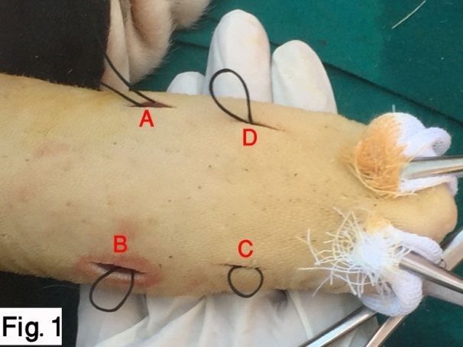
Figure legends
Fig.1. A complete stitch prior to knotting and induction of convexity of dorsal lingual surface (A, B, C and D, denote the left caudal, right caudal, right rostral and left rostral stab incisions respectively).
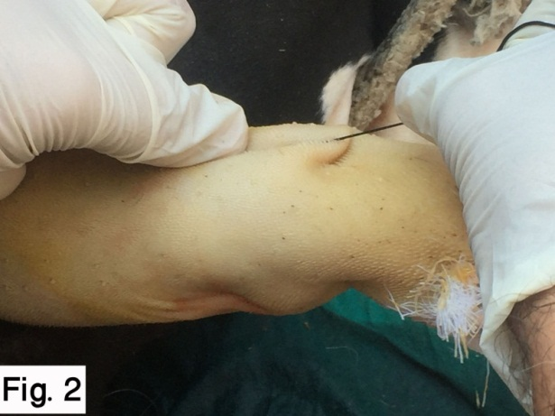
Fig.2. Securing the knot with pulling the thread to induce the required degree of convexity of dorsal lingual surface.

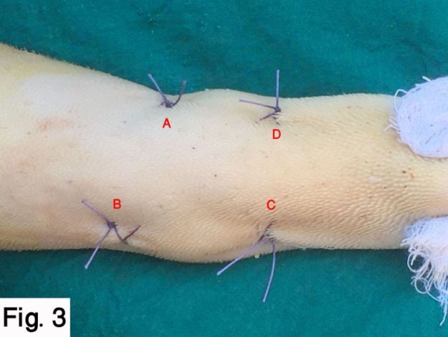
Fig.3. Shape of the tongue after completing the silk stitch and burring it, and closure of the mucosal stabs by cross mattress stitches using polyglactin 910 No. 0, (A, B, C, and D denote the four stab incisions), notice the convexity of the dorsal lingual aspect.
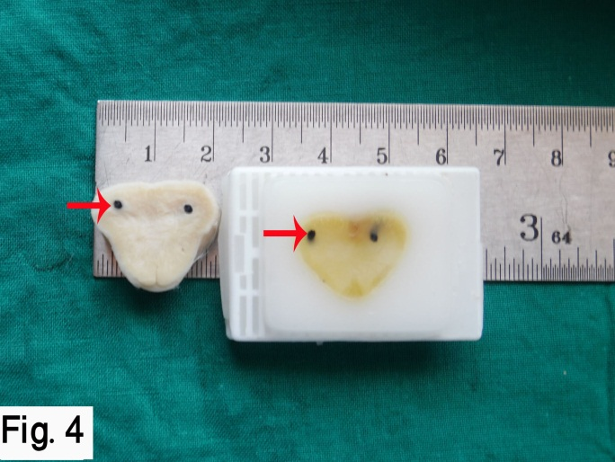
Fig.4. Gross photo showing cross section of the goat’s tongue where the silk material existed without gross inflammatory changes like redness, swelling or exudation. Red arrows denote cross section of the dorsal quadrant of the silk stitch under dorsal lingual mucosa, among the superficial muscular layers.
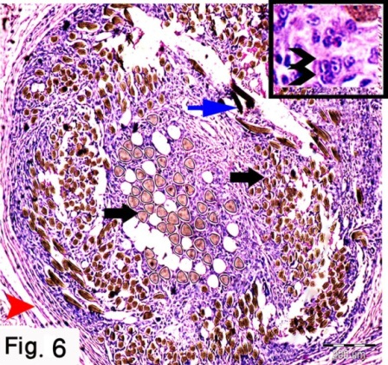
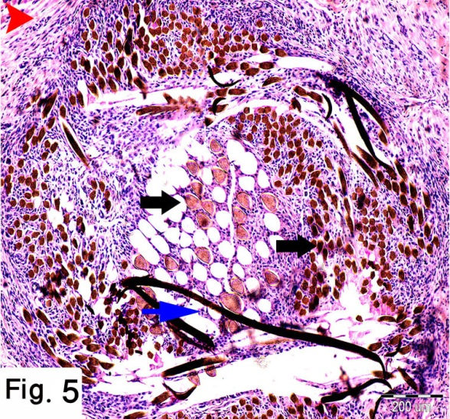
Fig.5. Paraffin section, of the goat’s tongue stained by Heamtoxylin and eosin, shows suture granulomatous structure composed of filaments of the silk (blue arrow), aggregated phagocytic giant cells engulfed the silk materials in its cytoplasm (black arrows), and mononuclear inflammatory cell infiltration, in addition to dense fibrous connective tissue (red arrow heads) inside and encircled the granuloma, which is infiltrated by variable amounts of lymphocyte. The bar size is indicated in the lower right corner of the picture.
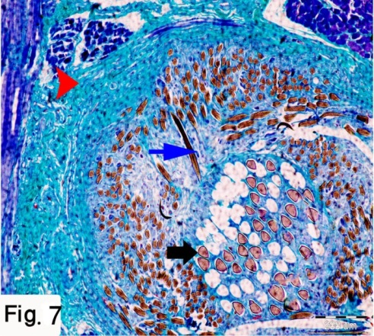
Fig.6. Paraffin sections, of the goat’s tongue stained by Heamtoxylin and eosin, shows suture granulomatous structure composed of scattered filaments of the silk material (blue arrow), aggregated phagocytic giant cells (black arrows), and degenerated macrophages (double arrow heads in the selected square), in addition to dense fibrous connective tissue capsule (red arrow heads). The bar size is indicated in the lower right corner of the picture.
Fig.7. Paraffin sections, of the goat’s tongue stained by Crossmon’s trichrome, shows suture granulomatous structure composed of filaments of the suture material (blue arrow), aggregated phagocytic giant cells engulfed the silk materials (black arrows), and dense fibrous connective tissue inside and encircled the granuloma (red arrow head). The bar size is indicated in the lower right corner of the picture.

